**Keeping Out Airborne Bacteria And Viruses With An Air Purifier**

Did you know that bacteria and viruses can survive longer in the ambient air in humid weather conditions? Well, that’s true and does explain the bouts of flu and other illnesses that come along with monsoons in India. Thus, keeping airborne bacteria and viruses from your home must be a priority for the safety of your family. Today, we are sharing some steps to help you do just that.

Ventilation

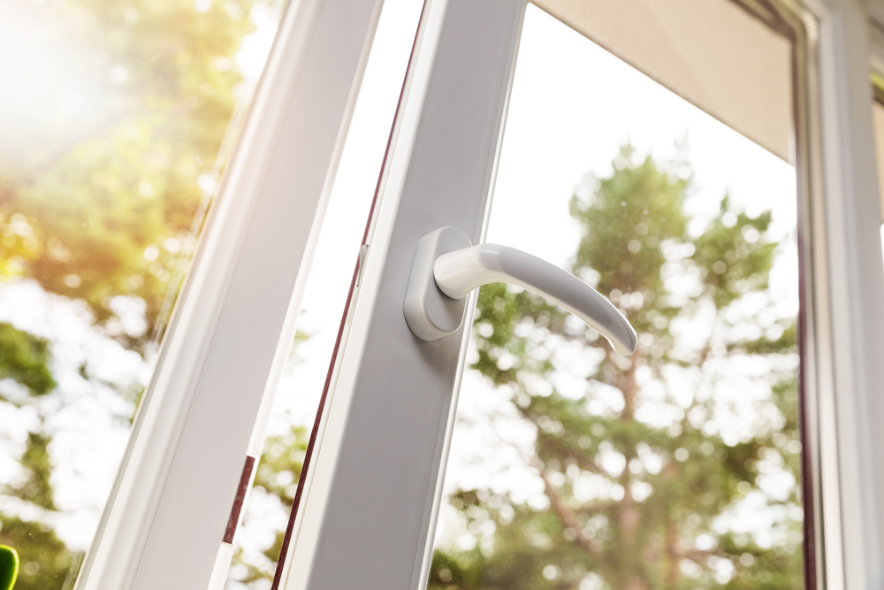

The age-old method of ensuring proper air flow through a building is the best way to keep humidity from building up inside your home. Open the doors and windows in the wee hours of morning to ensure that cool air passes through your home and replaces the indoor air. However, if you are living near a busy road, make sure to do this when the traffic levels are at their absolute low. You can also use exhaust fans and other mechanical means to ventilate your home if the outdoor air pollution is high.

Purification

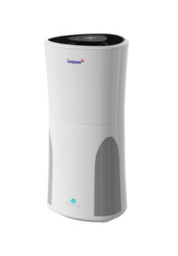

Once you have replaced the indoor air, it is essential to purify it. While the replaced air will be certainly less polluted than the indoor air, it may still have bacteria, viruses, particulate matter and volatile organic compounds that got unsettled when the indoor air moved out of your home. Using an [air purifier](https://www.livpure.com/air-purifier) to clean the indoor air will remove over 99 percent of these airborne pollutants. Modern air purifiers also come with an activated carbon filter to permanently remove organic (bacteria and viruses) and inorganic (formaldehyde, carbon monoxide, etc.) compounds from the air.

Maintenance

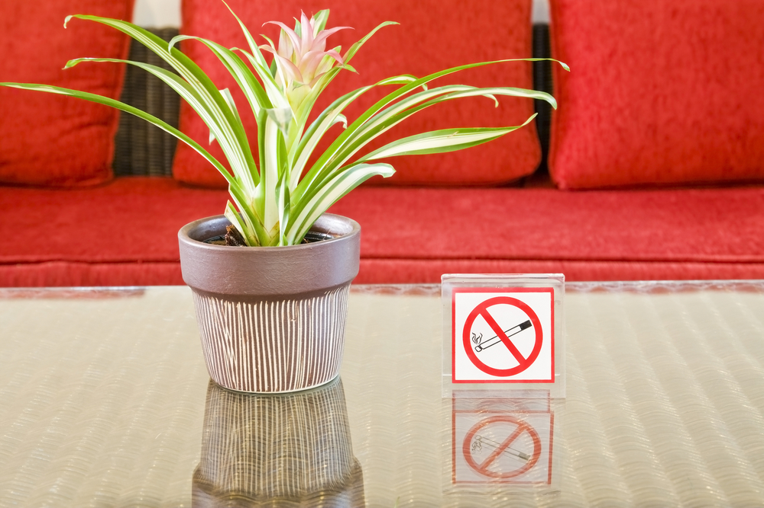

Now that you have clean air to breathe in, it is essential that those levels are maintained. While the air purifier will keep the air clean as long as you keep it running, there are several other things you can do to help it become more efficient. For starters, don’t bring dusty or muddy shoes indoors, do not smoke inside the home, and get a chimney for the kitchen. If you have pets then make sure that they are groomed regularly to reduce the amount of pet dander and pet hair flying around. Also, ensure that the HEPA filter inside your air purifier is replaced timely.

Ventilation



The age-old method of ensuring proper air flow through a building is the best way to keep humidity from building up inside your home. Open the doors and windows in the wee hours of morning to ensure that cool air passes through your home and replaces the indoor air. However, if you are living near a busy road, make sure to do this when the traffic levels are at their absolute low. You can also use exhaust fans and other mechanical means to ventilate your home if the outdoor air pollution is high.

Purification



Once you have replaced the indoor air, it is essential to purify it. While the replaced air will be certainly less polluted than the indoor air, it may still have bacteria, viruses, particulate matter and volatile organic compounds that got unsettled when the indoor air moved out of your home. Using an [air purifier](https://www.livpure.com/air-purifier) to clean the indoor air will remove over 99 percent of these airborne pollutants. Modern air purifiers also come with an activated carbon filter to permanently remove organic (bacteria and viruses) and inorganic (formaldehyde, carbon monoxide, etc.) compounds from the air.

Maintenance



Now that you have clean air to breathe in, it is essential that those levels are maintained. While the air purifier will keep the air clean as long as you keep it running, there are several other things you can do to help it become more efficient. For starters, don’t bring dusty or muddy shoes indoors, do not smoke inside the home, and get a chimney for the kitchen. If you have pets then make sure that they are groomed regularly to reduce the amount of pet dander and pet hair flying around. Also, ensure that the HEPA filter inside your air purifier is replaced timely.

from：<https://www.livpure.com/blog/keeping-out-airborne-bacteria-and-viruses-with-an-air-purifier>